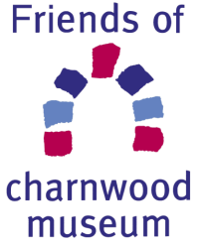

Friends of Charnwood Museum

Privacy Policy 2018

Your Personal Data and Friends of Charnwood Museum
Your confidentiality is protected by the Data Protection Act and, from 25 May 2018, the General Data Protection Regulation (GDPR) (Regulation (EU) 2016/679) and the Privacy and Electronic Communications Regulations 2016 (PECR). Any personal information supplied by you to Friends of Charnwood Museum will be kept on file. We will always store these personal details securely and delete them once they are no longer relevant, with the exception of consent removals.

Members
When you fill in Membership Application you are asked to provide Friends of Charnwood Museum with some Personal Data. We will also ask you to consent to which ways you wish Friends of Charnwood Museum to communicate with you. You can opt out of any/all of our communications at any time by contacting the Membership Secretary: viv.lawfam@ntlworld.com
We will use the data to provide the service that you expect as a result of your membership of Friends of Charnwood Museum and will communicate with you in the way(s) you have agreed to. The data we hold will be used to send you notice of talks and other Friends events, subscription information, AGM information, news of events held by Charnwood Museum and by other organisations with similar objectives.
Friends of Charnwood Museum will only allow your information to be used by others working on our behalf and will only share it if required to do so by law. We will never share your information with other companies or charities for marketing purposes.
You have the right of access to a copy of the information Friends of Charnwood Museum holds about you (a subject access request), obtainable subject to proof of identity, from Friends of Charnwood Museum Membership Secretary, at the email address above.

Approved by Friends of Charnwood Museum Committee: February 2018
Review Date: 2021

